Ideation Phase
Brainstorm & Idea Prioritization Template
Date | 12 July 2026
Team ID | [Enter Team ID]
Project Name | Smart Lender – Loan Approval Prediction System
Maximum Marks | 4 Marks

Step 1: Team Gathering & Problem Statement Selection
The team reviewed both problem statements from the previous exercise and selected PS-1 (the credit officer's need for a fast, consistent, data-driven risk score) as the driving problem for the brainstorming session.

Step 2: Brainstorm, Idea Listing & Grouping
Category | Ideas generated
Data & ML | - Rule-based (if/else) eligibility checklist  - Single ML classifier trained on historical applicant data  - Train several classifiers (Decision Tree, Random Forest, KNN, XGBoost) and auto-select the best  - Explainable AI (SHAP/feature-importance) to justify each decision
User Experience | - Web form for officers to key in applicant details  - Mobile app for field agents  - Chatbot-guided intake  - Confidence gauge / visual meter on the result screen instead of a bare Yes/No
Automation & Integration | - Bulk CSV upload for batch evaluation of many applicants  - Live credit-bureau API integration  - Scheduled retraining pipeline when new data arrives
Trust & Operations | - Model comparison report so the team can see why a model was chosen  - Persisted preprocessing artifacts (encoders/scaler) for reproducible predictions  - Cloud deployment (IBM Cloud Foundry / Code Engine) for team-wide access

Step 3: Idea Prioritization
Ideas were plotted on an impact-vs-feasibility matrix to decide what belongs in the MVP versus the backlog.
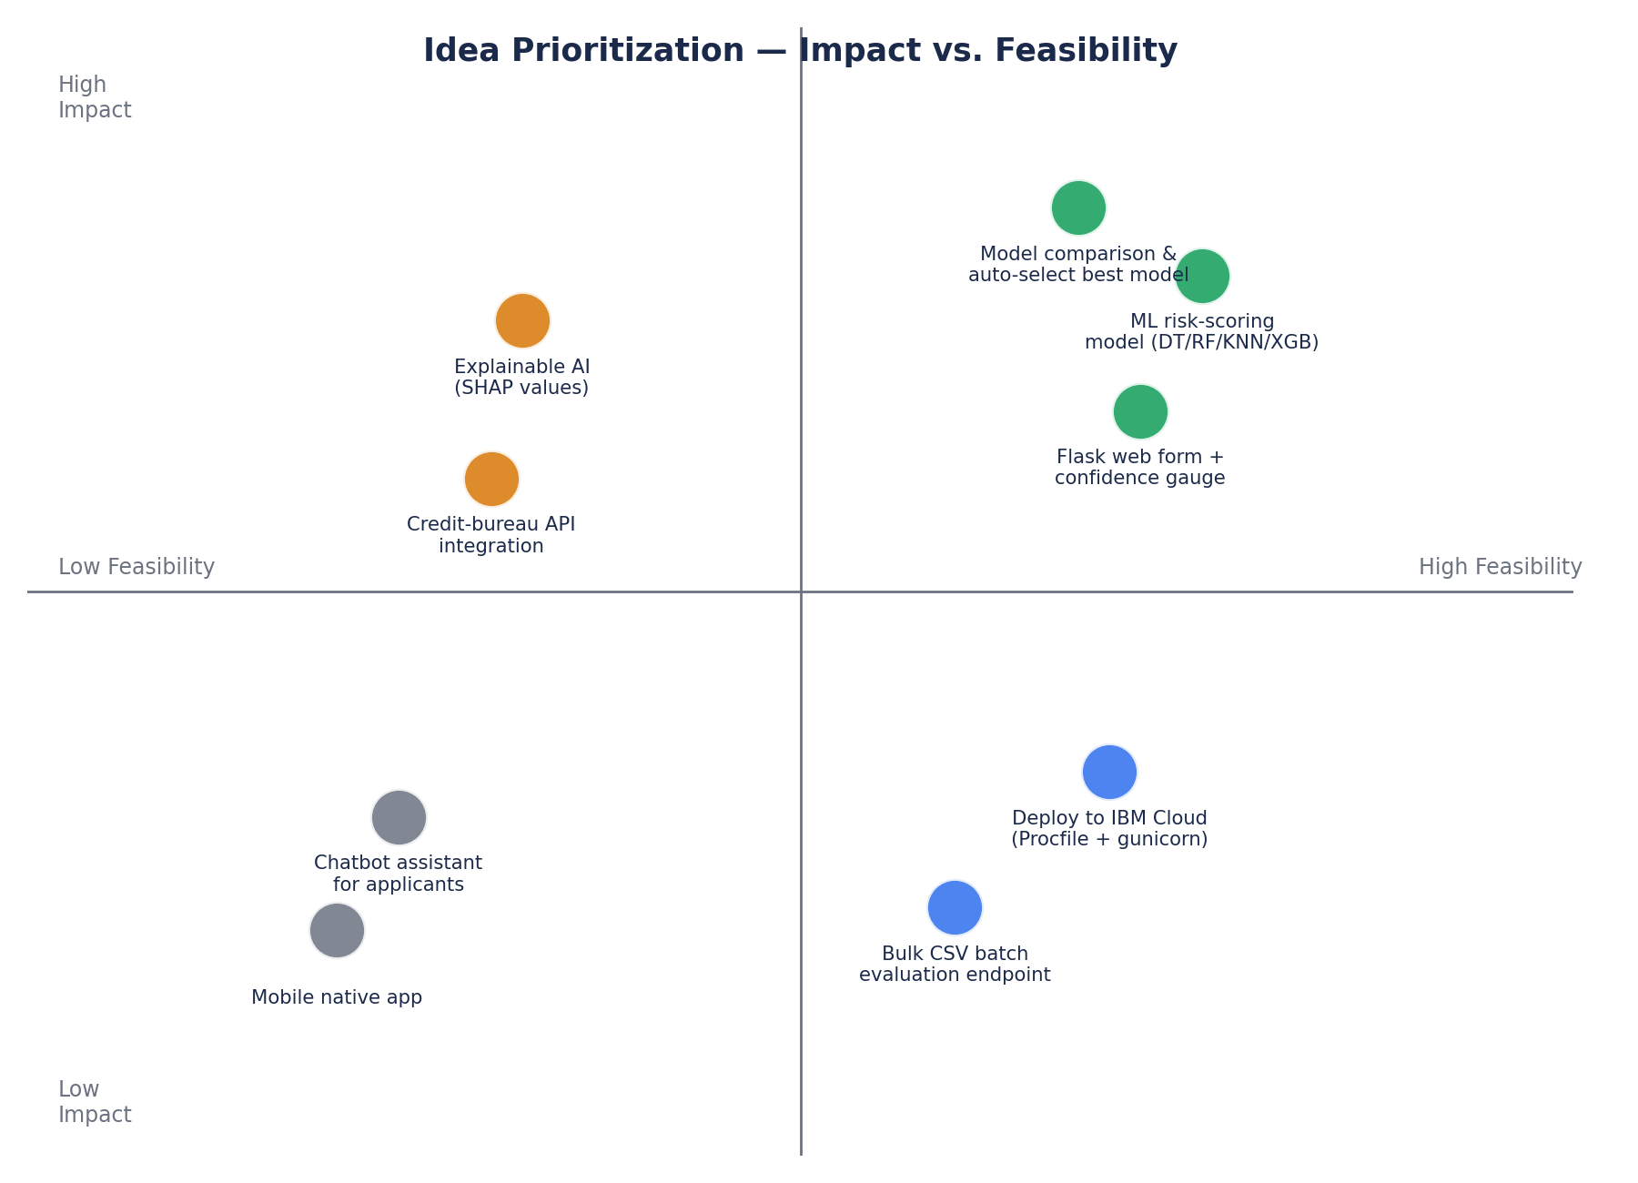
Idea | Quadrant | Decision
Multi-model ML classifier with auto-selection | High impact / High feasibility | Build now — core of MVP
Flask web form + confidence gauge | High impact / High feasibility | Build now — core of MVP
Cloud deployment (Procfile/gunicorn) | High impact / Medium feasibility | Build now
Bulk CSV batch evaluation endpoint | Medium impact / High feasibility | Fast-follow, post-MVP
Explainable AI (SHAP values) | High impact / Low feasibility (time) | Backlog
Credit-bureau API integration | High impact / Low feasibility (external dependency) | Backlog
Chatbot assistant / native mobile app | Low impact / Low feasibility | Parked

